4. Implementation of the following Memory Allocation Methods for fixed partition a. First Fit b. Worst Fit c. Best Fit
import random
import matplotlib.pyplot as plt
import pandas as pd

method = input("Enter allocation method (first / best / worst): ").lower()
n_blocks = int(input("Enter number of blocks: "))
n_files = int(input("Enter number of files: "))

block_status = [random.randint(0, 1) for _ in range(n_blocks)]
block_sizes = [random.randint(10, 60) if b == 0 else 0 for b in block_status]
file_sizes = [random.randint(5, 30) for _ in range(n_files)]

allocation = [-1] * n_files
fragment = [0] * n_files
used = [False] * n_blocks

free_blocks = [(block_sizes[i], i) for i in range(n_blocks) if block_status[i] == 0]

if method == "best":
free_blocks.sort()
elif method == "worst":
free_blocks.sort(reverse=True)

for i in range(n_files):
for size, idx in free_blocks:
if size >= file_sizes[i] and not used[idx]:
allocation[i] = idx
fragment[i] = size - file_sizes[i]
used[idx] = True
break

print("\nFile_no File_size Block_no Block_size Fragment")
print("-"*50)
for i in range(n_files):
if allocation[i] != -1:
print(f"{i+1:<8}{file_sizes[i]:<11}{'B'+str(allocation[i]+1):<10}{block_sizes[allocation[i]]:<12}{fragment[i]}")
else:
print(f"{i+1:<8}{file_sizes[i]:<11}{'NA':<10}{'NA':<12}{'NA'}")

block_to_file = {}
for i, b in enumerate(allocation):
if b != -1:
block_to_file[b] = f"P{i+1}"

fig, ax = plt.subplots(figsize=(4, 9))
ax.set_xlim(0, 1)
ax.set_ylim(0, n_blocks)
ax.axis("off")

for i in range(n_blocks):
y = n_blocks - i - 1

ax.text(-0.05, y + 0.5, f"B{i+1}", ha="right", va="center", weight="bold")

if block_status[i] == 1:
ax.add_patch(plt.Rectangle((0, y), 1, 1, color="yellow", ec="black"))
ax.text(0.5, y + 0.5, "USED", ha="center", va="center", weight="bold")

elif used[i]:
ax.add_patch(plt.Rectangle((0, y), 1, 1, color="green", ec="black"))
label = block_to_file.get(i, "")
ax.text(0.5, y + 0.5, f"{label}\n{block_sizes[i]} KB",
ha="center", va="center", fontsize=10, weight="bold")

else:
ax.add_patch(plt.Rectangle((0, y), 1, 1, color="white", ec="black"))
ax.text(0.5, y + 0.5, f"{block_sizes[i]} KB", ha="center", va="center")

ax.set_title(
f"Memory Allocation using {method.upper()} Fit (OS View)",
fontsize=13, fontweight="bold", pad=15
)

plt.show()
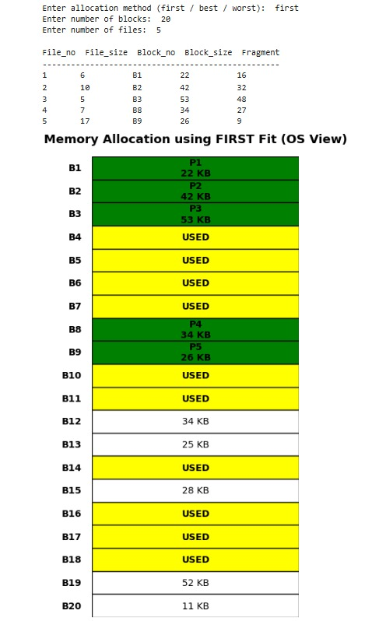
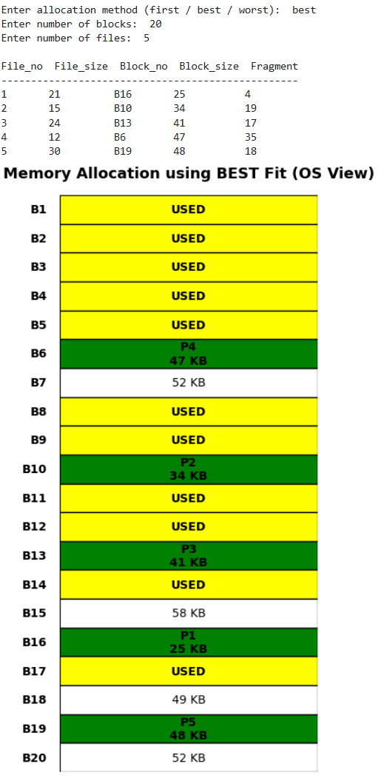
Output:

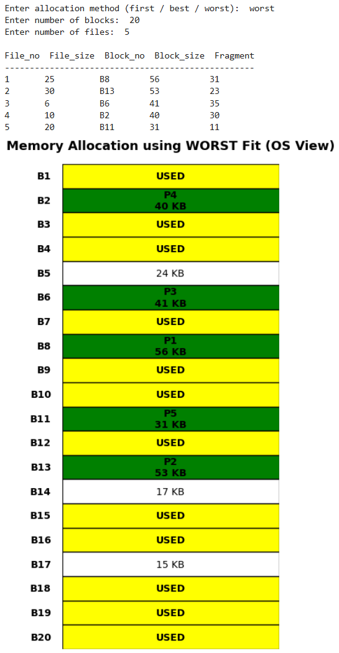

6. Implementation of the following Page Replacement Algorithms a. FIFO b. LRU c. optimal
import random
import matplotlib.pyplot as plt

def get_victim_index(algo, frames, pages, current_idx, recent_usage, fifo_q):
if algo == "FIFO":
return fifo_q, (fifo_q + 1) % len(frames)

if algo == "LRU":
victim = min(frames, key=lambda x: recent_usage[x])
return frames.index(victim), fifo_q

if algo == "OPTIMAL":
future = pages[current_idx+1:]
victim = max(frames, key=lambda x: future.index(x) if x in future else float('inf'))
return frames.index(victim), fifo_q

def simulate(pages, cap, algo):
frames, history, status, repl_str = [], [], [], []
faults, fifo_q = 0, 0
recent = {}

for i, p in enumerate(pages):
recent[p] = i

if p in frames:
status.append("HIT"); repl_str.append("-")
else:
faults += 1
status.append("FAULT")

if len(frames) < cap:
frames.append(p)
repl_str.append(f"->{p}")
else:
idx, fifo_q = get_victim_index(algo, frames, pages, i, recent, fifo_q)
repl_str.append(f"{frames[idx]}->{p}")
frames[idx] = p

history.append(frames[:])

return faults, history, status, repl_str

try:
n = int(input("Ref string size: "))
cap = int(input("Frame slots: "))
choice = int(input("1.FIFO 2.LRU 3.OPTIMAL\nChoice: "))
algos = {1: "FIFO", 2: "LRU", 3: "OPTIMAL"}
algo = algos[choice]
except (ValueError, KeyError):
exit("Invalid Input")

pages = [random.randint(1, 9) for _ in range(n)]
faults, history, status, repl = simulate(pages, cap, algo)

print(f"\nAlgorithm: {algo}\nFrames: {cap}\nTotal Pages: {n}\nHits: {n-faults}\nFaults: {faults}\nRef String: {pages}")

table_data = [
[h[i] if i < len(h) else "" for h in history]
for i in range(cap)
] + [status, repl]

row_labels = [f"Frame {i+1}" for i in range(cap)] + ["Status", "Change"]

plt.figure(figsize=(max(10, n*0.8), 5))
plt.axis('off')
plt.title(f"{algo} Page Replacement Simulation", fontsize=14, weight='bold')
tbl = plt.table(cellText=table_data, rowLabels=row_labels, colLabels=list(map(str, pages)), loc='center', cellLoc='center')
tbl.scale(1, 1.5)
plt.tight_layout()
plt.show()

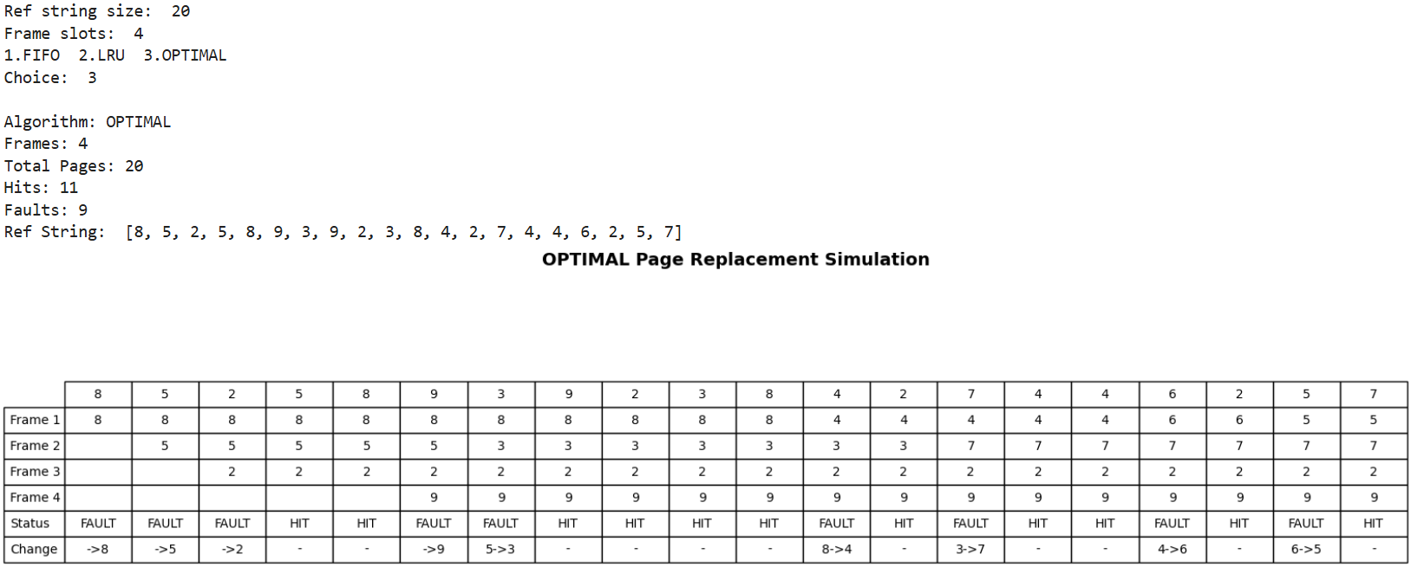
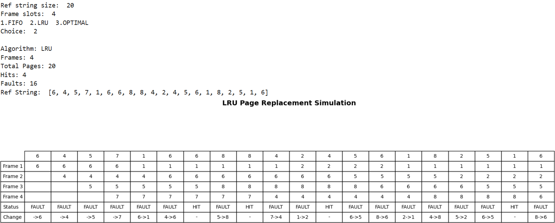
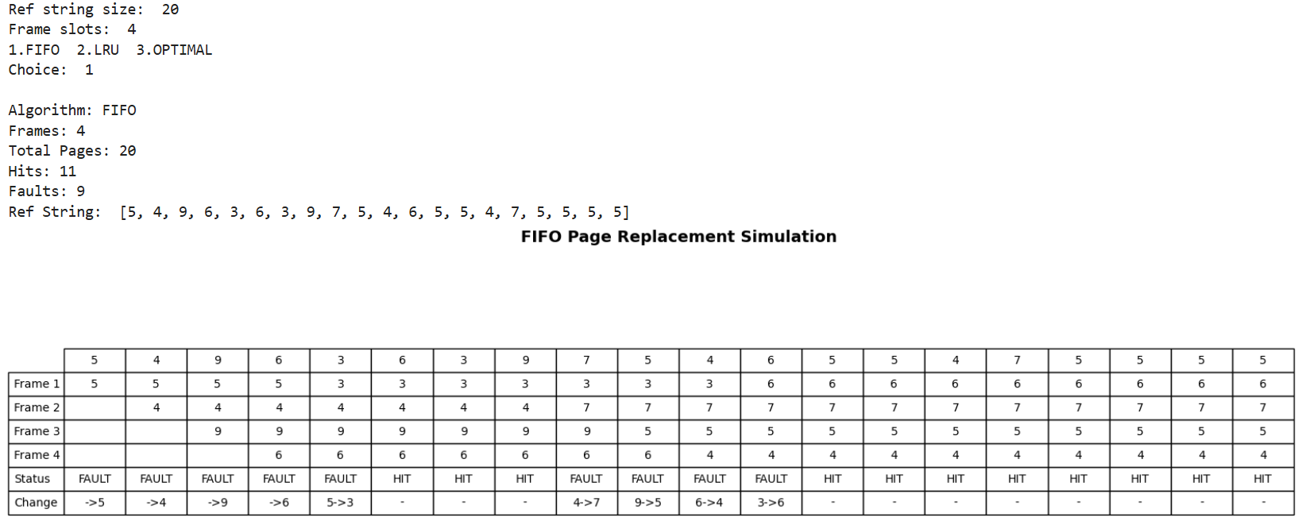
Output:

7. Simulate frame allocation Methods. a. minimum number of frames b. equal allocation c. proportional allocation
import random
import pandas as pd
import matplotlib.pyplot as plt

n = int(input("Enter number of processes: "))
total_frames = int(input("Enter total number of frames: "))
min_frames = int(input("Enter minimum frames per process: "))

print("\nChoose Allocation Method:")
print("1. Minimum Allocation")
print("2. Equal Allocation")
print("3. Proportional Allocation")

choice = int(input("Enter choice (1/2/3): "))

processes = [f"P{i+1}" for i in range(n)]
sizes = [random.randint(5, 25) for _ in range(n)]

if choice == 1:
allocated = [min_frames] * n
title = "Minimum Frame Allocation"

elif choice == 2:
allocated = [total_frames // n] * n
title = "Equal Frame Allocation"

elif choice == 3:
total_size = sum(sizes)
allocated = [(s * total_frames) // total_size for s in sizes]
title = "Proportional Frame Allocation"

else:
print("Invalid choice")
exit()

used_frames = sum(allocated)
free_frames = total_frames - used_frames
df = pd.DataFrame({
"Process": processes,
"Process_Size(Pages)": sizes,
"Frames_Allocated": allocated
})

print("\nFrame Allocation Table:\n")
print(df.to_string(index=False))
print(f"\nUnallocated Frames: {free_frames}")

fig, ax = plt.subplots(figsize=(12, 3))

start = 0
colors = plt.cm.tab20.colors

for i in range(n):
ax.barh(0, allocated[i], left=start, color=colors[i], label=processes[i])
ax.text(start + allocated[i]/2, 0, processes[i],
ha="center", va="center", color="white", fontsize=10)
start += allocated[i]

# Free frames
if free_frames > 0:
ax.barh(0, free_frames, left=start, color="gray", label="Free")
ax.text(start + free_frames/2, 0, "Free", ha="center", va="center")

for f in range(total_frames + 1):
ax.axvline(f, color="black", linewidth=0.3)

ax.set_xlim(0, total_frames)
ax.set_yticks([])
ax.set_xlabel("Frame Number")
ax.set_title(title)

ax.set_xticks(range(0, total_frames + 1))

plt.tight_layout()
plt.show()

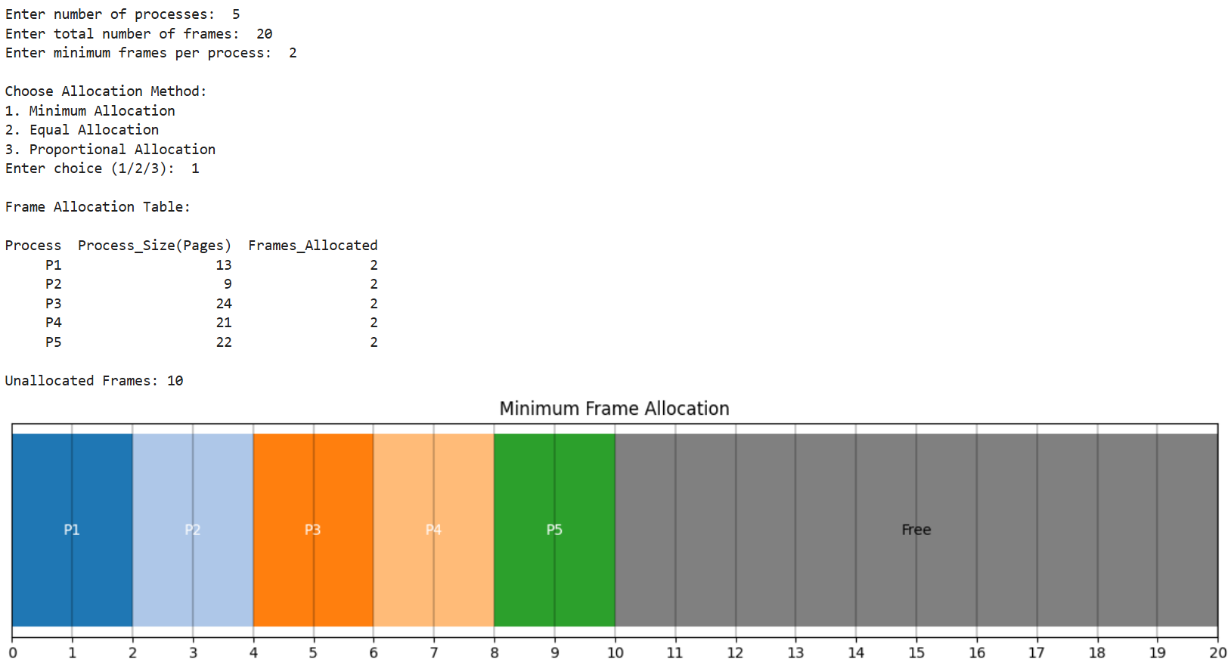
Output:

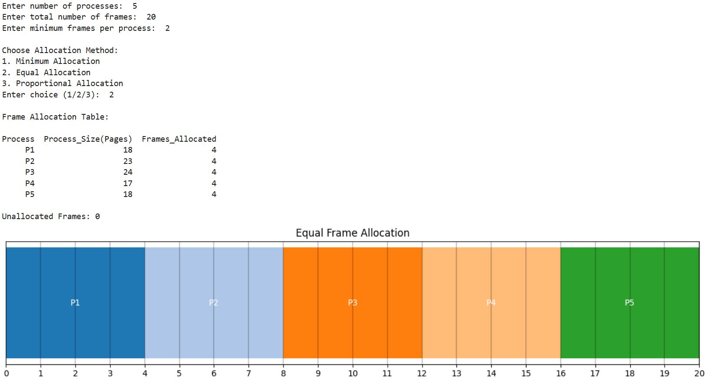

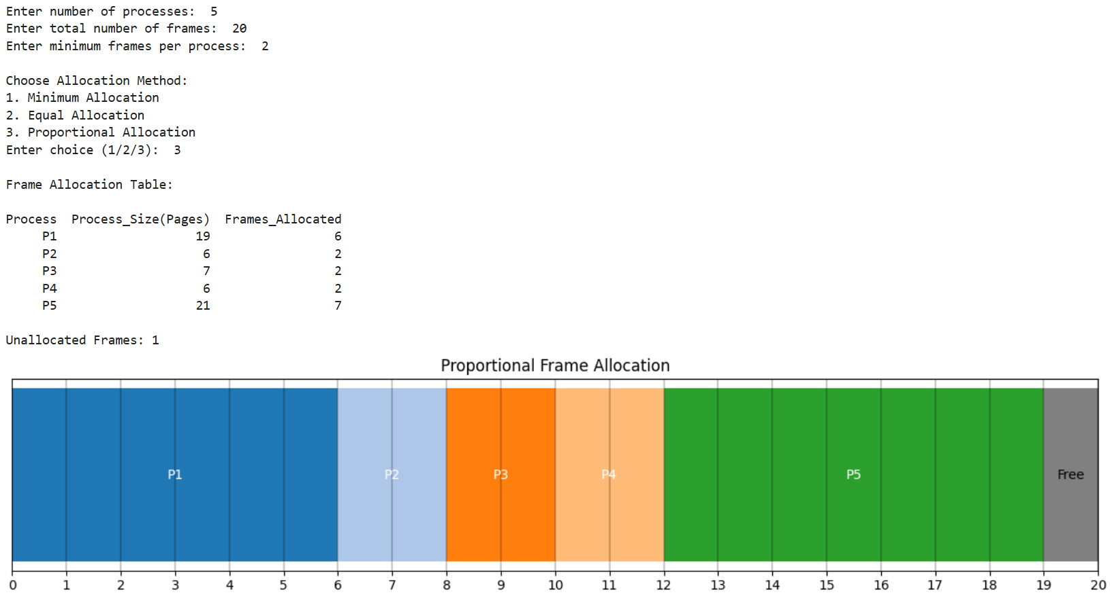

3. Simulate Bankers Algorithm for Deadlock Avoidance.
p = int(input("No of Processes: "))
r = int(input("No of Resources: "))
a = []
m = []
print("Enter Allocation Matrix:")
for i in range(p):
a.append(list(map(int, input().split())))

print("Enter Max Matrix:")
for i in range(p):
m.append(list(map(int, input().split())))

print("Enter Available Resources:")
av = list(map(int, input().split()))

n = []
for i in range(p):
row = []
for j in range(r):
row.append(m[i][j] - a[i][j])
n.append(row)

print("\nProcess\tAllocation\tMax\tNeed")
for i in range(p):
print(f"P{i}\t{a[i]}\t{m[i]}\t{n[i]}")

w = av.copy()
f = [0]*p
seq = []

for _ in range(p):
ok = False
for i in range(p):
if not f[i] and all(n[i][j] <= w[j] for j in range(r)):
for j in range(r):
w[j] += a[i][j]
seq.append(i)
f[i] = 1
ok = True
if not ok:
break
if len(seq) == p:
print("\nSystem is in SAFE state")
print("Sequence:", " -> ".join(f"P{i}" for i in seq))
else:
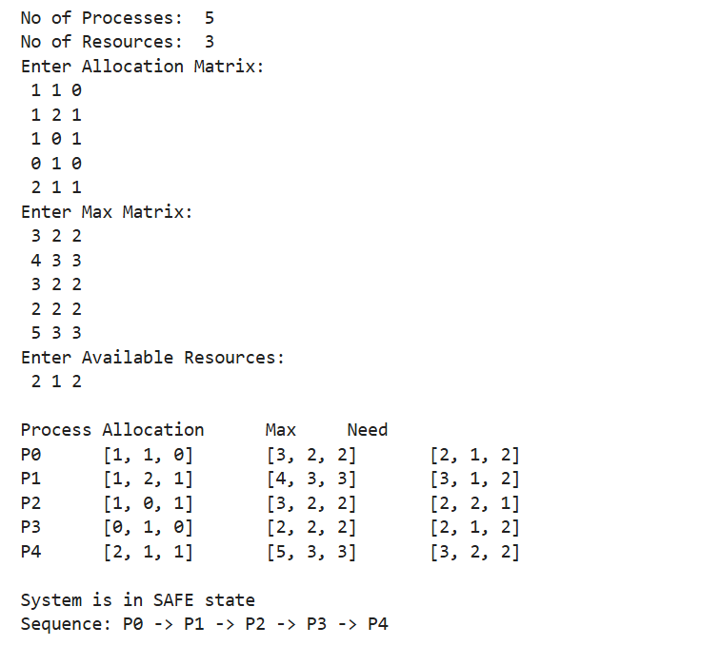
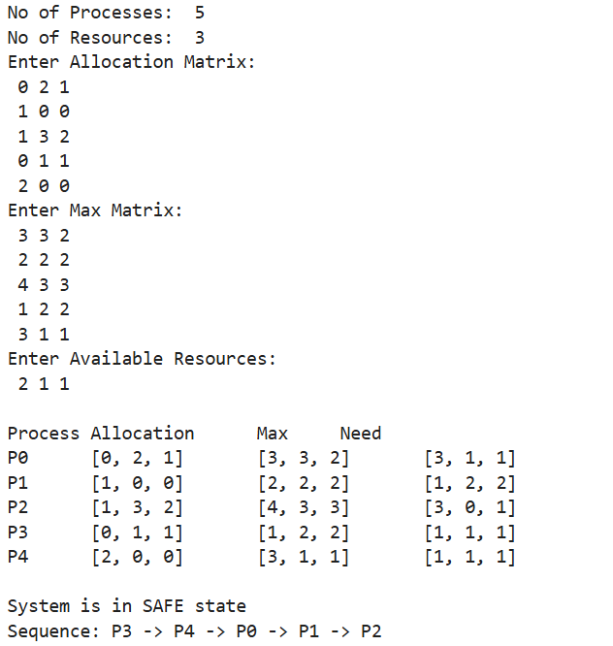
print("\nSystem is NOT in safe state")
Output:

8. Simulate the following Disk scheduling algorithms.
a. FCFS b. SSTF c. SCAN
import random
import matplotlib.pyplot as plt

def plot_graph(order, title):
plt.figure(figsize=(12,6))
plt.plot(order, range(len(order)), marker='o')
plt.gca().invert_yaxis()
plt.xlabel("Cylinder Number")
plt.ylabel("Step Number")
plt.title(title)
plt.show()

def fcfs(queue, head):
order = [head] + queue
total = 0
for i in range(len(order)-1):
total += abs(order[i+1] - order[i])

print("\nFCFS")
print("Service Order:", order)
print("Total Head Movement:", total)
plot_graph(order, "FCFS Disk Scheduling")

def sstf(queue, head):
requests = queue.copy()
current = head
order = [head]
total = 0
for _ in range(len(requests)):
nearest = requests[0]
min_dist = abs(nearest - current)
for r in requests:
if abs(r - current) < min_dist:
nearest = r
min_dist = abs(r - current)
total += min_dist
current = nearest
order.append(nearest)
requests.remove(nearest)

print("\nSSTF")
print("Service Order:", order)
print("Total Head Movement:", total)
plot_graph(order, "SSTF Disk Scheduling")

def scan(queue, head, start, end, direction):
left = [x for x in queue if x < head]
right = [x for x in queue if x >= head]

left.sort()
right.sort()
order = [head]
if direction == "left":
left.reverse()
order += left
order.append(start)
order += right
else:
order += right
order.append(end)
left.reverse()
order += left
total = 0
for i in range(len(order)-1):
total += abs(order[i+1] - order[i])

print("\nSCAN")
print("Service Order:", order)
print("Total Head Movement:", total)
plot_graph(order, "SCAN Disk Scheduling")

start = int(input("Enter start cylinder: "))
end = int(input("Enter end cylinder: "))
qsize = int(input("Enter queue size: "))

queue = [random.randint(start, end) for _ in range(qsize)]
head = random.randint(start, end)

print("\nGenerated Queue:", queue)
print("Head Position:", head)
print("\n----- Disk Scheduling Menu -----")
print("1. FCFS")
print("2. SSTF")
print("3. SCAN")
choice = int(input("Enter choice: "))

if choice == 1:
fcfs(queue, head)
elif choice == 2:
sstf(queue, head)
elif choice == 3:
print("\nDirection:")
print("1. Left")
print("2. Right")
d = input("Enter direction: ")

if d == "1":
direction = "left"
elif d == "2":
direction = "right"
else:
print("Invalid direction")
exit()

scan(queue, head, start, end, direction)
else:
print("Invalid choice")
Output:
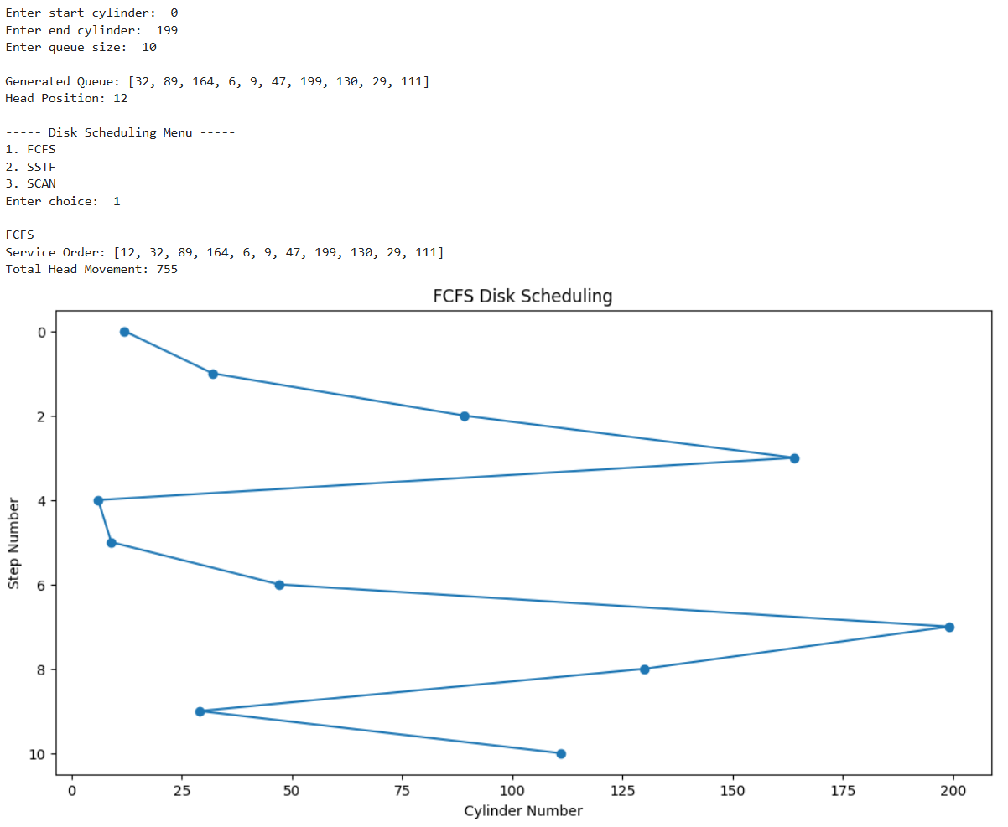
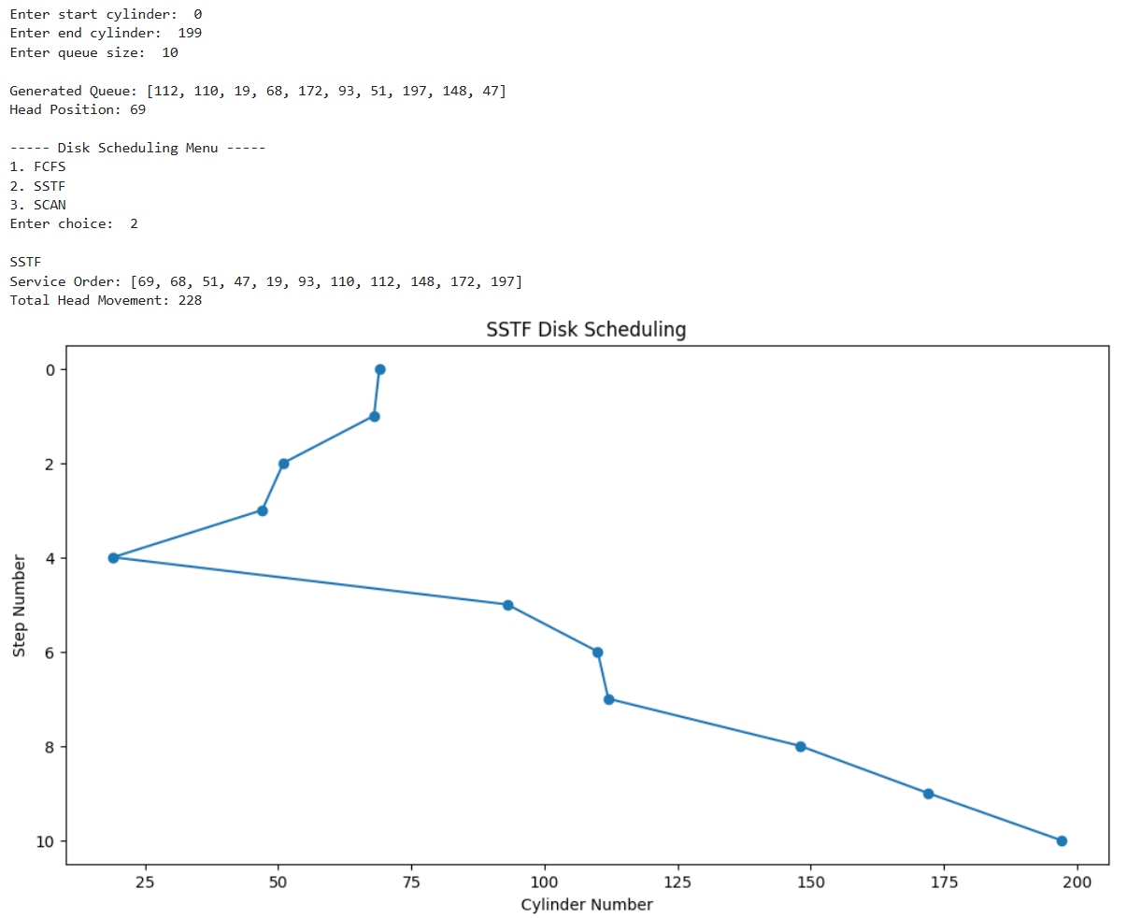
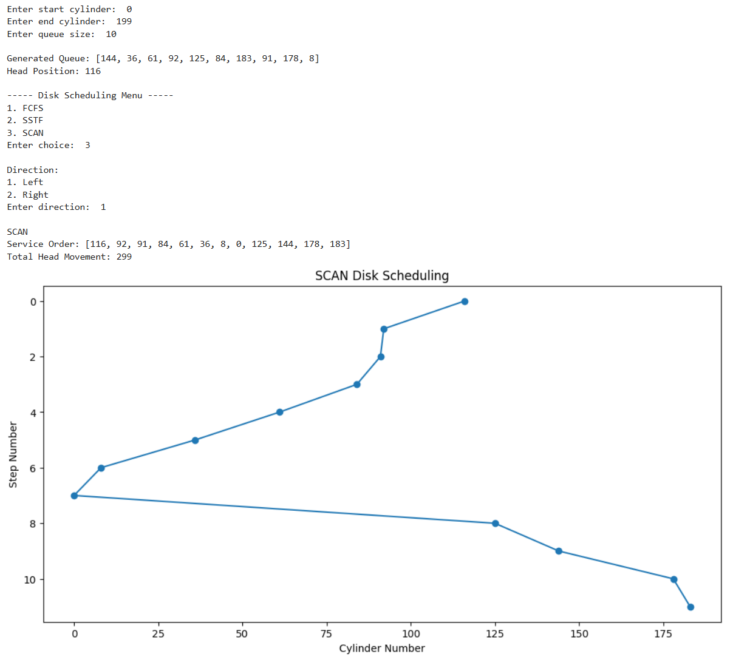

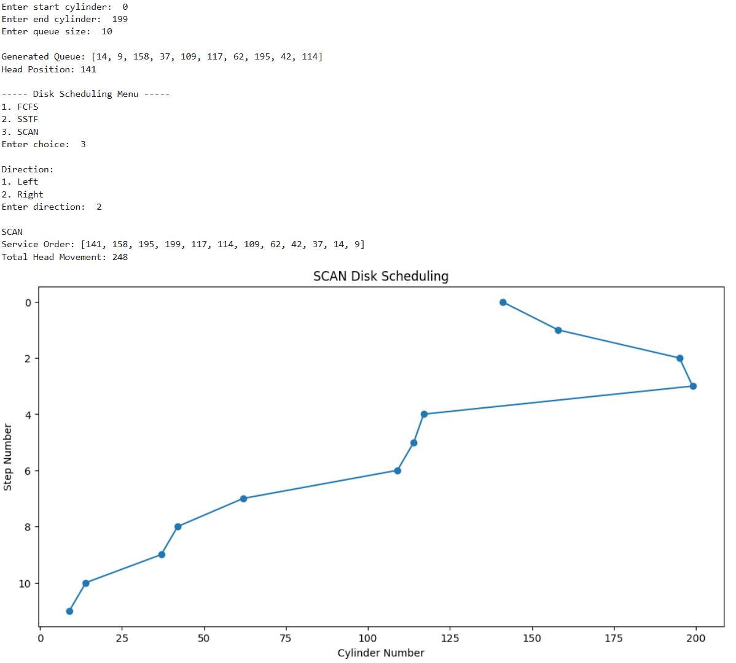

9. Simulate the following Disk scheduling algorithms.
a. C-SCAN b. LOOK c. C-LOOK

import random
import matplotlib.pyplot as plt

def plot_graph(order, title):
plt.figure(figsize=(12, 6))
y = [i/2 for i in range(len(order))]
plt.plot(order, y, marker='o')
plt.gca().invert_yaxis()
plt.xlabel("Cylinder Number")
plt.ylabel("Step Number")
plt.title(title)
plt.show()

def cscan(queue, head, start, end, direction):
left = sorted([x for x in queue if x < head])
right = sorted([x for x in queue if x >= head])

order = [head]

if direction == "right":
order += right
order.append(end)
order.append(start)
order += left

else: # left
order += left[::-1]
order.append(start)
order.append(end)
order += right[::-1]
total = 0
for i in range(len(order)-1):
total += abs(order[i+1] - order[i])

print("\nC-SCAN ")
print("Service Order:", order)
print("Total Head Movement:", total)

plot_graph(order, "C-SCAN Disk Scheduling")

def look(queue, head, direction):

left = sorted([x for x in queue if x < head])
right = sorted([x for x in queue if x >= head])

order = [head]

if direction == "right":
order += right
order += left[::-1]
else:
order += left[::-1]
order += right

total = 0
for i in range(len(order)-1):
total += abs(order[i+1] - order[i])

print("\nLOOK")
print("Service Order:", order)
print("Total Head Movement:", total)

plot_graph(order, "LOOK Disk Scheduling")

def clook(queue, head, direction):

left = sorted([x for x in queue if x < head])
right = sorted([x for x in queue if x >= head])

order = [head]

if direction == "right":
order += right
order += left

else:
order += left[::-1]
order += right[::-1]
total = 0
for i in range(len(order)-1):
total += abs(order[i+1] - order[i])

print("\nC-LOOK")
print("Service Order:", order)
print("Total Head Movement:", total)
plot_graph(order, "C-LOOK Disk Scheduling")

start = int(input("Enter start cylinder: "))
end = int(input("Enter end cylinder: "))
qsize = int(input("Enter queue size: "))

queue = [random.randint(start, end) for _ in range(qsize)]
head = random.randint(start, end)
print("\nQueue:", queue)
print("Head:", head)
print("\n----- MENU -----")
print("1. C-SCAN")
print("2. LOOK")
print("3. C-LOOK")
choice = int(input("Enter choice: ")
print("\nDirection:")
print("1. Left")
print("2. Right")
d = int(input("Enter direction: "))
if d == 1:
direction = "left"
elif d == 2:
direction = "right"
else:
print("Invalid direction")
exit()
if choice == 1:
cscan(queue, head, start, end, direction)
elif choice == 2:
look(queue, head, direction)
elif choice == 3:
clook(queue, head, direction)
else:
print("Invalid choice")
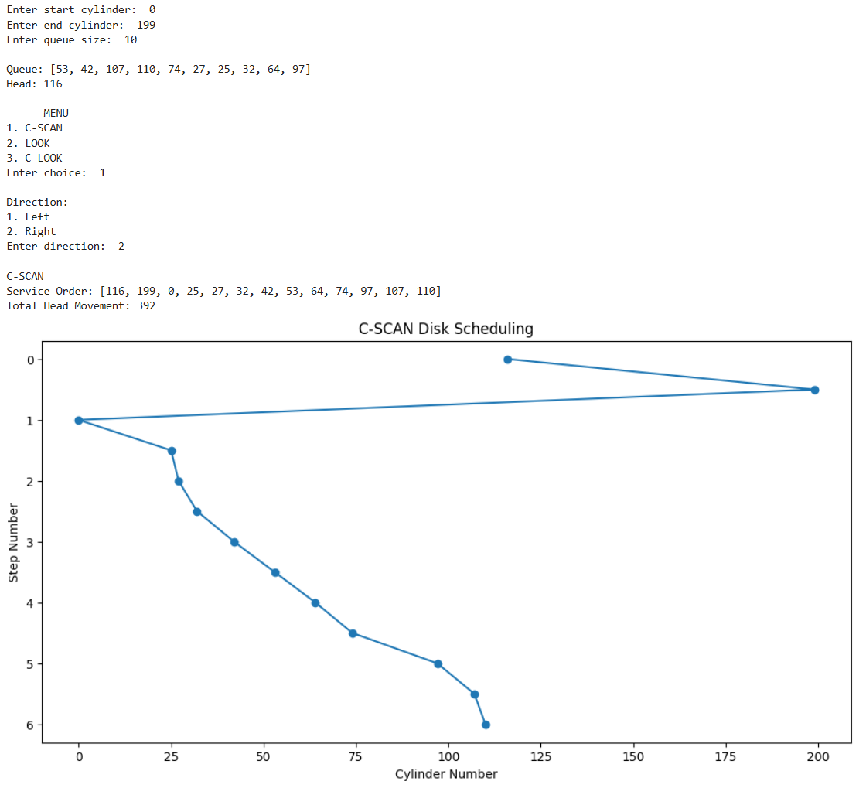
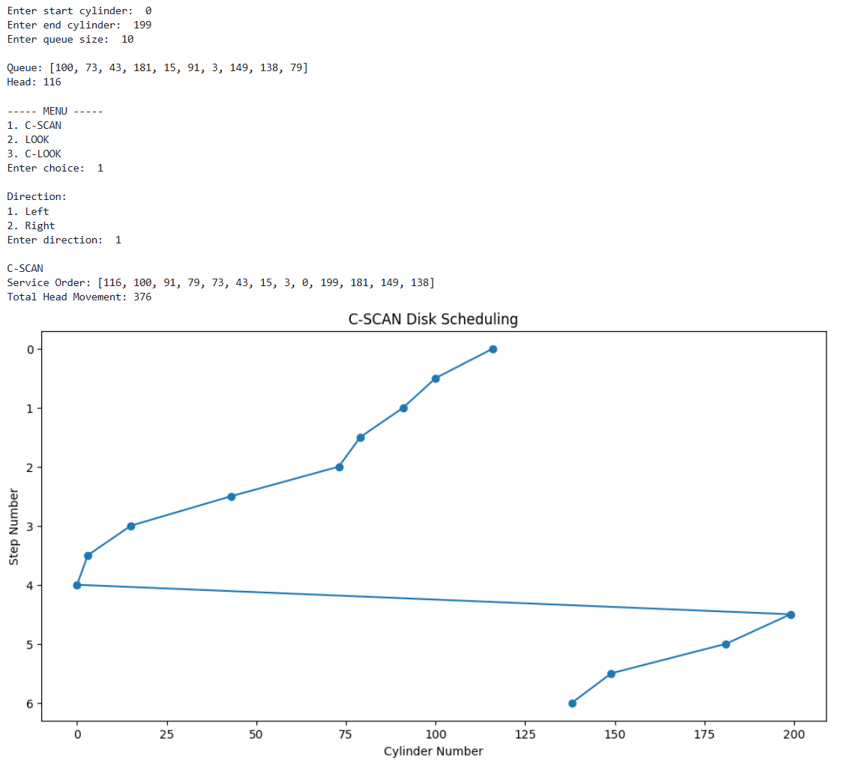
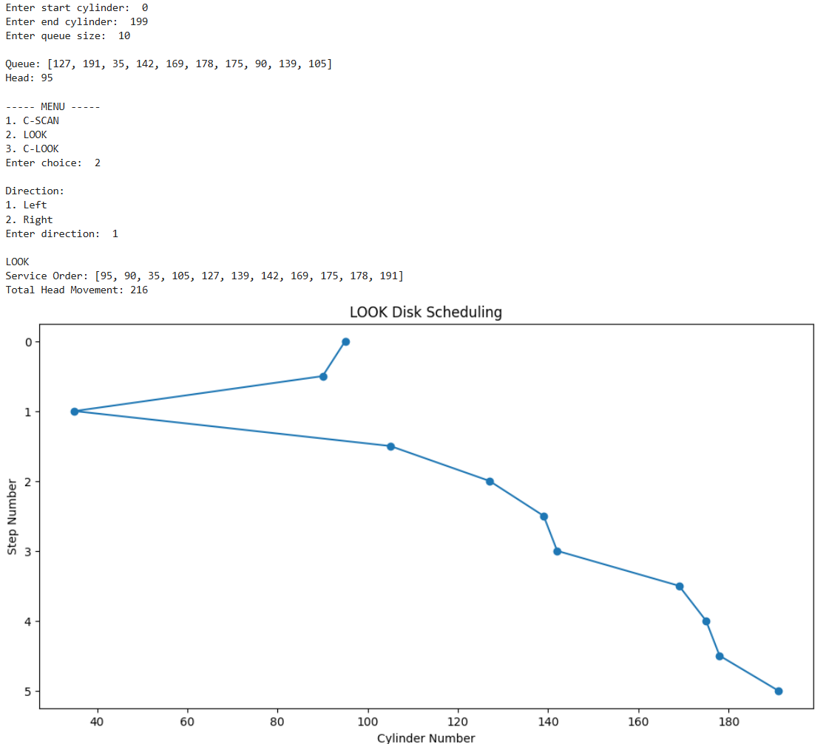
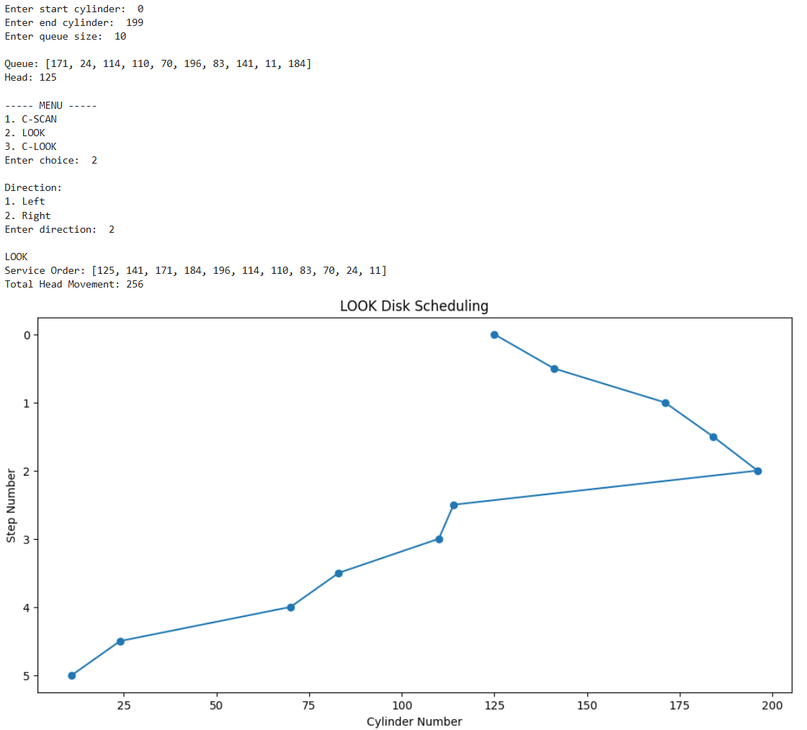
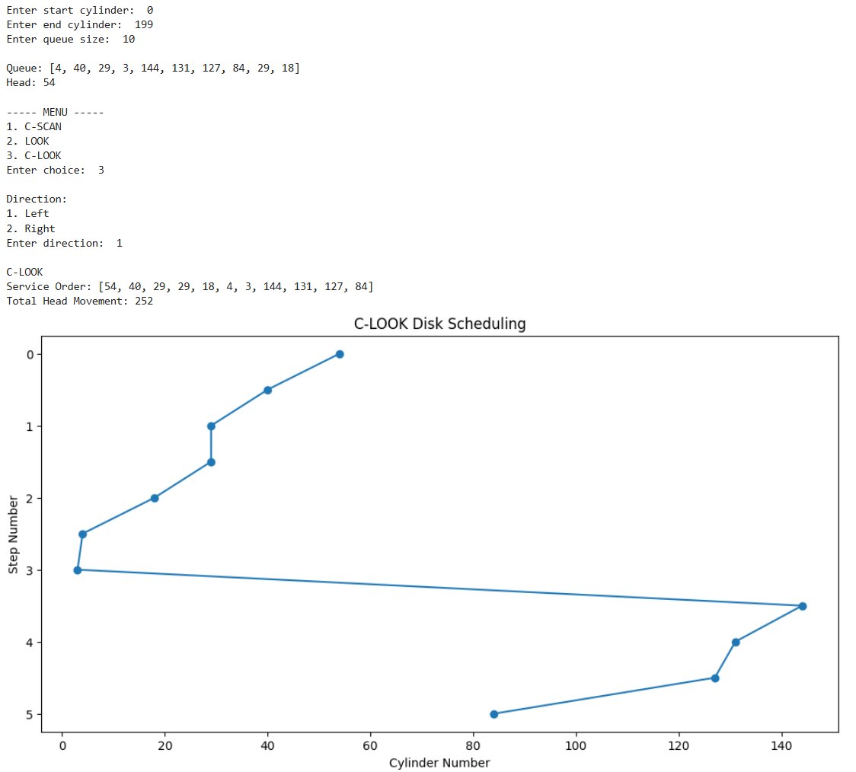

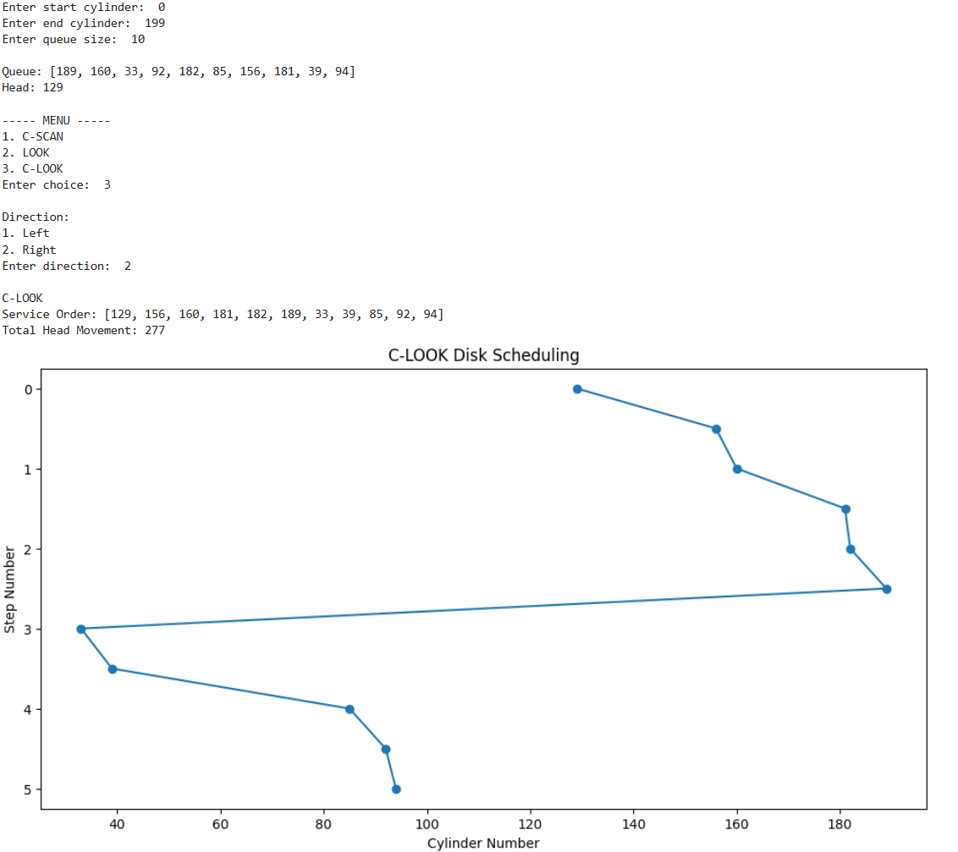
10. Simulate all file allocation strategies. a) Sequential b) Indexed c) Linked.
import random

n = int(input("Enter number of locations: "))
disk = [False] * n

for i in range(n):
if random.random() < 0.4:
disk[i] = True

print("\nInitial Disk State:")
print(["1" if x else "0" for x in disk])

print("\nChoose Allocation Method:")
print("1) Sequential Allocation")
print("2) Linked Allocation")
print("3) Indexed Allocation")

choice = int(input("Enter choice: "))
num_files = int(input("Enter number of files: "))

for f in range(1, num_files + 1):
print(f"\n--- Allocating File F{f} ---")
size = random.randint(1, 5)
print("File size:", size)

if choice == 1:
allocated = False
for i in range(n - size + 1):
if not any(disk[i:i+size]):
for j in range(i, i+size):
disk[j] = True

print("Allocated blocks:", list(range(i, i+size)))
print(f"Stored at positions: {i} to {i+size-1}")
allocated = True
break

if not allocated:
print("Allocation failed (no contiguous space)")

elif choice == 2:
free_blocks = [i for i in range(n) if not disk[i]]

if len(free_blocks) < size:
print("Allocation failed (not enough space)")
else:
blocks = random.sample(free_blocks, size)

for b in blocks:
disk[b] = True

print("Allocated blocks (linked):")
print(" -> ".join(map(str, blocks)))
print("Stored at positions:", blocks)

elif choice == 3:
free_blocks = [i for i in range(n) if not disk[i]]

if len(free_blocks) < size + 1:
print("Allocation failed (need index + data blocks)")
else:
index_block = free_blocks[0]
data_blocks = random.sample(free_blocks[1:], size)

disk[index_block] = True
for b in data_blocks:
disk[b] = True

print("Index Block:", index_block)
print("Data Blocks:", data_blocks)
print(f"{index_block} -> {data_blocks}")

else:
print("Invalid choice")

print("Disk state:", ["1" if x else "0" for x in disk])

Output:
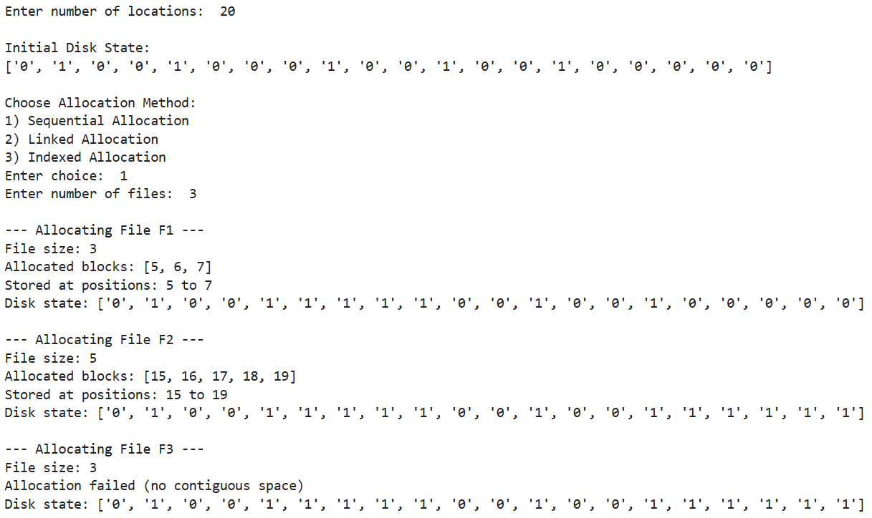

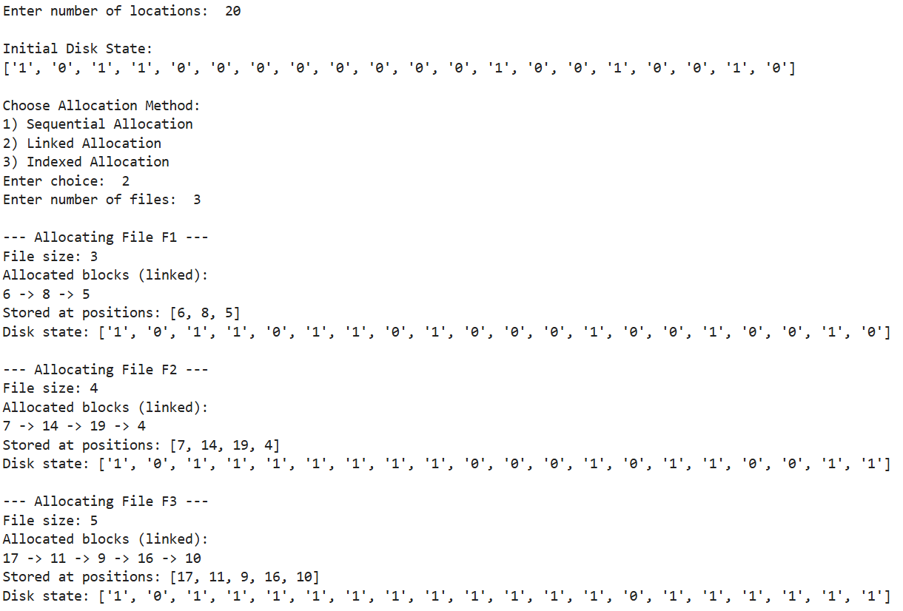
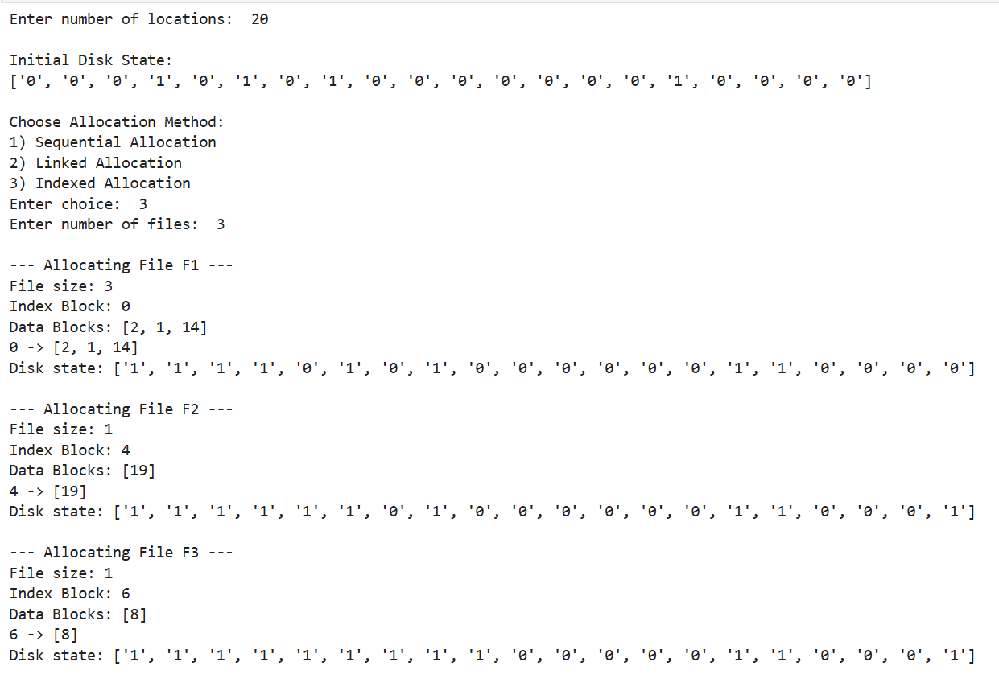

5. Implementation of Paging Technique of Memory Management
import random
import math

page_size = int(input("Enter page (frame) size: "))
process_size = int(input("Enter process size: "))
memory_size = int(input("Enter main memory size: "))

if page_size <= 0 or process_size <= 0 or memory_size <= 0:
print("Error: All inputs must be positive!")
exit()

if (page_size & (page_size - 1)) != 0:
print("Error: Page size must be a power of 2!")
exit()

if memory_size % page_size != 0:
print("Error: Memory size must be a multiple of page size!")
exit()

if process_size > memory_size:
print("Error: Process size should be less than or equal to main memory size!")
exit()

num_pages = (process_size + page_size - 1) // page_size
num_frames = memory_size // page_size

if num_pages > num_frames:
print("Error: Not enough memory to allocate all pages!")
exit()

offset_bits = int(math.log2(page_size))
page_bits = int(math.ceil(math.log2(num_pages)))
frame_bits = int(math.ceil(math.log2(num_frames)))
physical_bits = frame_bits + offset_bits

print("\nNumber of pages:", num_pages)
print("Number of frames:", num_frames)

free_frames = list(range(num_frames))
page_table = {}

for i in range(num_pages):
frame = random.choice(free_frames)
page_table[i] = frame
free_frames.remove(frame)

print("\nPage Table (Random Allocation):")
for p in page_table:
print(f"Page {p} -> Frame {page_table[p]}")

print("\nByte -> (Page, Offset) -> Frame -> Physical Address:\n")

for byte in range(process_size):
page_no = byte // page_size
offset = byte % page_size
frame_no = page_table[page_no]

physical_address = frame_no * page_size + offset

byte_bin = format(byte, f'0{page_bits + offset_bits}b')
page_bin = format(page_no, f'0{page_bits}b')
offset_bin = format(offset, f'0{offset_bits}b')
frame_bin = format(frame_no, f'0{frame_bits}b')
physical_bin = format(physical_address, f'0{physical_bits}b')

print(f"Byte {byte} ({byte_bin}) -> "
f"(Page {page_no} ({page_bin}), Offset {offset} ({offset_bin})) -> "
f"Frame {frame_no} ({frame_bin}) -> "
f"Physical Address {physical_address} ({physical_bin})")

Output:

